1. **Search engine optimization** (**SEO**)
   1. **Introduction**

Search engine optimization (SEO) is the process of increasing the [visibility](https://en.wikipedia.org/wiki/Discoverability) of a [website](https://en.wikipedia.org/wiki/Website) or a [web page](https://en.wikipedia.org/wiki/Web_page) to users of a [web search engine](https://en.wikipedia.org/wiki/Web_search_engine). The term excludes the purchase of [paid placement](https://en.wikipedia.org/wiki/Online_advertising), referring only to the improvement of unpaid results (known as as "natural" or "[organic](https://en.wikipedia.org/wiki/Organic_search)" results).

SEO is performed because a website will receive more visitors from a search engine the higher the website appears in the search results page. These visitors can then be converted into customers.[[1]](https://en.wikipedia.org/wiki/Search_engine_optimization#cite_note-1) SEO may target different kinds of search, including [image search](https://en.wikipedia.org/wiki/Image_search), [video search](https://en.wikipedia.org/wiki/Video_search), [academic search](https://en.wikipedia.org/wiki/Academic_databases_and_search_engines),[[2]](https://en.wikipedia.org/wiki/Search_engine_optimization#cite_note-aseo-2) news search, and industry-specific [vertical search](https://en.wikipedia.org/wiki/Vertical_search) engines. SEO differs from [local search engine optimization](https://en.wikipedia.org/wiki/Local_search_engine_optimisation) in that the latter is focused on optimizing a business' online presence so that its web pages will be displayed by search engines when a user enters a [local search](https://en.wikipedia.org/wiki/Local_search_(Internet)) for its products or services. The former instead is more focused on national or international searches.

As an [Internet marketing](https://en.wikipedia.org/wiki/Internet_marketing) strategy, SEO considers how search engines work, the computer programmed [algorithms](https://en.wikipedia.org/wiki/Algorithm) which dictate search engine behavior, what people search for, the actual search terms or [keywords](https://en.wikipedia.org/wiki/Keyword_research) typed into search engines, and which search engines are preferred by their targeted audience. Optimizing a website may involve editing its content, adding content, doing [HTML](https://en.wikipedia.org/wiki/HTML), and associated coding to both increase its relevance to specific keywords and to remove barriers to the [indexing activities](https://en.wikipedia.org/wiki/Web_crawler) of search engines. Promoting a site to increase the number of [backlinks](https://en.wikipedia.org/wiki/Backlinks), or inbound links, is another SEO tactic. By May 2015, [mobile search](https://en.wikipedia.org/wiki/Mobile_search) had surpassed desktop search.[[3]](https://en.wikipedia.org/wiki/Search_engine_optimization#cite_note-3) In 2015, it was reported that [Google](https://en.wikipedia.org/wiki/Google) is developing and promoting mobile search as a key feature within future products. In response, many brands are beginning to take a different approach to their Internet marketing strategies.

## 6.2 Working of SEO

Google (and Bing, which also power Yahoo search results) score their search results largely based upon **relevancy and authority** of pages it has crawled and included in its web index, to a user’s query to provide the best answer.

Google uses over 200 signals in scoring their search results and SEO encompasses technical and creative activities to influence and improve some of those known signals. It’s often useful to not focus too much on individual ranking signals and look at the wider goal of Google, **to provide the best answers for its users**.

SEO, therefore, involves making sure a website is accessible, technically sound, uses words that people type into the search engines, and provides an excellent user experience, with useful and high quality, expert content that helps answers the user’s query.

Google has a very large team of search quality ratters that evaluate the quality of search results, that gets fed into a machine learning algorithm. Google’s [search quality ratter guidelines](https://www.screamingfrog.co.uk/media/www.google.com/en/insidesearch/howsearchworks/assets/searchqualityevaluatorguidelines.pdf) provide plenty of detail and examples of what Google class as high or low quality content and websites, and their emphasis on wanting to reward sites that clearly show their expertise, authority and trust (EAT).

Google uses a hyperlink-based algorithm (known as ‘PageRank’) to calculate the popularity and authority of a page, and while Google is far more sophisticated today, this is still a fundamental signal in ranking. SEO can therefore also include activity to help improve the number and quality of ‘inbound links’ to a website, from other websites. This activity has historically been known as ‘link building’, but is really just marketing a brand with an emphasis online, through content or digital PR for example.

Relevant and reputable websites linking to a website is a strong signal to Google that it might be of interest to its users, and can be trusted to appear in the search results for relevant queries.

# 6.3 Google Webmaster Tool

Google Webmaster Tools is a free service that helps you evaluate and maintain your website's performance in search results (1). Offered as a free service to anyone who owns a website, Google Webmaster Tools (GWT) is a conduit of information from the largest search engine in the world to you, offering insights into how it sees your website and helping you uncover issues that need fixing.

You do not need to use GWT for your website to appear in search results, but it can offer you valuable information that can help with your marketing efforts.

#### **GWT can help monitor your website's performance**

1. It verifies that Google can access the content on your website.  
2. GWT makes it possible to submit new pages and posts for Google to crawl and remove content you don't want search engine users to discover.  
3. It helps you deliver and evaluate content that offers users a more visual experience.  
4. You can maintain your website without disrupting its presence in search results.  
5. It allows you to discover and eliminate malware or spam problems that may not be easily found through other means.

#### **GWT helps you understand how Google search views your website**

1. It tells you the most popular queries causing your website to appear in search results.  
2. It tells you which queries are driving the most traffic.  
3. You can see which websites are linking to yours.  
4. You can evaluate how well your mobile website is performing for people searching on tablets and phones.

#### **Set up GWT**

Before accessing any data, you have to verify that you are the owner, or authorized representative, of the website. There are five ways you can verify your website. One is not really better than the other, so you can choose which option is the easiest for you (2).

**Uploading an HTML file** - Google gives you a file with a specific name that you have to upload to the root directory of your website. The file itself is blank. Its only purpose is to help prove that you have access to the website's FTP server and can drop files where they need to go. Once the file goes into the root directory, just click on the "verify" button in GWT, and you will have access to data.

**Adding an HTML tag** - You can also verify the website by adding a meta tag provided by Google that you can drop into the header of your homepage. Once this is in place, click on the "verify" button to view data. It's important to note that sometimes homepage code can be challenging to find with certain content management system (CMS) themes, particularly WordPress. It is also possible that your code might disappear when you update your homepage, revoking your access to GWT data until the tag is replaced.

**Select the provider of your domain** - Google gives you the option of selecting your domain name provider in a drop-down list. Click on your provider, and Google will walk you through the steps of verifying your website.

**Use Google Analytics** - As the administrator of your website's Google Analytics account, you can verify the website using asynchronous tracking code placed in the head of your homepage.

**Using Google Tag Manager** - this is a tool that allows you to enter and manage all the tracking tags for your website, including GWT.

Once your account is set up and your website is verified, you will have access to plenty of actionable data that can help you optimize your website. You can receive alerts from Google, adjust settings to deliver specific information to your inbox, submit XML site maps and view user queries where your website appeared in search. Learn the basics of using GWT, and you will have a great resource on which to base your future marketing decisions.

#### **6.4 SEO Setup**

* **Robot.txt**
* **Sitemap.xml**

## Robots.txt

Robots.txt is a text file webmaster create to instruct web robots (typically search engine robots) how to crawl pages on their website. The robots.txt file is part of the the robots exclusion protocol (REP), a group of web standards that regulate how robots crawl the web, access and index content, and serve that content up to users. The REP also includes directives like [meta robots](https://moz.com/learn/seo/robots-meta-directives), as well as page-, subdirectory-, or site-wide instructions for how search engines should treat links (such as “follow” or “nofollow”).

In practice, [robots.txt files indicate](https://moz.com/blog/interactive-guide-to-robots-txt) whether certain user agents (web-crawling software) can or cannot crawl parts of a website. These crawl instructions are specified by “disallowing” or “allowing” the behaviour of certain (or all) user agents.

##### **Basic format:**

**User-agent: [user-agent name]**

**Disallow: [URL string not to be crawled]**

Together, these two lines are considered a [complete robots.txt file](https://support.google.com/webmasters/answer/6062596?hl=en) — though one robots file can contain multiple lines of user agents and directives (i.e., disallows, allows, crawl-delays, etc.).

Within a robots.txt file, **each set of user-agent directives appear as a discrete set,** separated by a line break

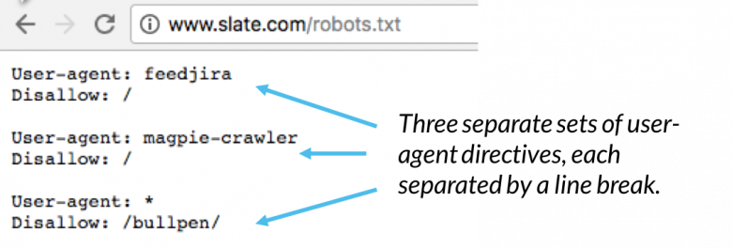

**Fig 6.4.1 robot.txt example**

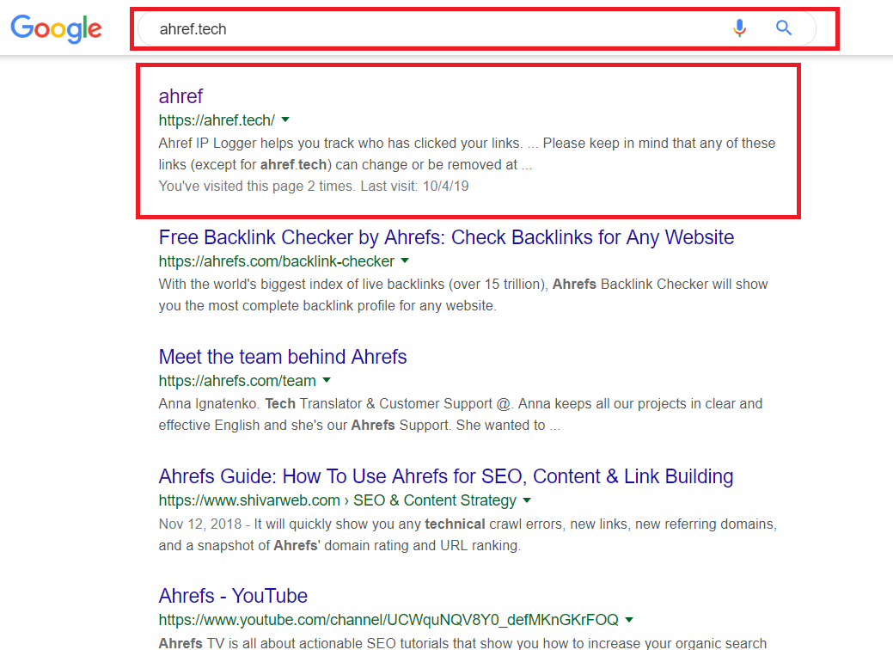In a robots.txt file with multiple user-agent directives, each disallow or allow rule**only** applies to the user agent(s) specified in that particular line break-separated set. If the file contains a rule that [applies to more than one user-agent](https://developers.google.com/webmasters/control-crawl-index/docs/robots_txt), a crawler will **only** pay attention to (and follow the directives in) the most specific group of instructions.

**Fig 6.4.2 robot.txt example of Ahref**

**Sitemap Setup**

In simple terms, a Sitemap is an XML file that is full of your individual webpage’s URLs. It’s like an archive of every webpage in your website. This file should be easily discoverable in your site in order for search engine crawlers to stumble upon it.

[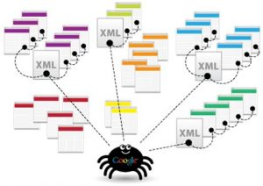](https://seohackercdn-seohacker.netdna-ssl.com/wp-content/uploads/2011/05/google-Sitemap-spider.jpg?x45503)

**Fig 6.4.3 How sitemap works**

A Sitemap is usually used for the purpose of letting the search engine crawlers follow the links to all your individual webpages so that it won’t miss out on anything.

Sometimes we leave out URLs or hide them from all visible pages because we don’t exactly want some of the users to go there. As a result, some of these URLs are uncrawlable to search engine spiders.

We can still leave those URLs hidden from some users without having to lose out on those pages not being crawled by search engine spiders through including them in an XML Sitemap.

**Get started with Sitemap**

A Sitemap is pretty easy to create. For WordPress users, you can download the [Google XML Sitemaps plugin](http://wordpress.org/extend/plugins/google-sitemap-generator/) to make it easier for you. This plugin helps you generate an XML sitemap without having to do anything but activating it.

After the plugin has generated your Sitemap, you can find the Sitemap at an address like this:

**http://YourURL/sitemap.xml**

[My Sitemap](https://seo-hacker.com/sitemap.xml) can be found at https://seo-hacker.com/sitemap.xmlbut I usually place the website’s Sitemap at the footer too so that it would have a stronger crawlable presence.

For those who are not using WordPress, you can use this [online XML-Sitemaps generator tool](http://www.xml-sitemaps.com/). It’s pretty easy and they provide a step-by-step approach for you to implement your own Sitemap in your website.

**Sitemap affect your SEO**

Search engines should see all the pages that you want them to see. The more pages that they index from you, the more trust your site gains. It only means that your website has more information to offer.

Making sure the search engine spiders get to crawl all the stuff they need to crawl from your website is the exact purpose of a Sitemap. It’s not for navigation, it’s not for internal linking. It’s for the search engine spiders.